**README FILE**

**Project Title: Personal Finance Dashboard**

**SAMIRA 35125-BSCS QURAIBA 36227-BSCS**

**Project Objectives:**

* Create a user-friendly platform for personal financial management.
* Provide secure and efficient tracking of financial transactions.
* Enable users to monitor their spending patterns and financial goals.
* Deliver insightful financial analytics and reports.

**Features:**

* User authentication and authorization: Log in and register securely.
* Personal Dashboard: A responsive interface displaying financial statistics.
* Goal Setting: Users can define and track financial goals.
* Dark Mode Support: The UI supports both light and dark themes.
* Smooth Navigation: Implemented with anchor links and smooth scrolling.
* Responsive UI framework.
* Local Storage: For theme preferences.
* Transaction Management
* Expense Tracking
* Budget Planning
* Financial Reports and Analytics
* Secure form submissions using validation and sanitization in PHP.
* Responsive Design
* Password recovery options

**Technologies Used:**

* HTML5
* CSS3
* JavaScript(ES6+) and AJAX calls
* Char.js for data visualization
* Bootstrap4.5.2 for responsive design and framework
* FontAwesome Icons
* Local Storage for data persistence and theme preferences
* jQuery : For DOM manipulation.
* PHP: Backend scripting
* MYSQL: database management

**Usage Instructions:**

* Open index.html in a web browser.
* Create an account or log in
* Set up your financial goals
* Add your budget categories
* Track your transactions
* Monitor your progress through the dashboard
* Toggle between light and dark themes as needed

**System Architecture and DesignArchitecture Overview:**

* **Frontend:** Responsive UI built with HTML5 and CSS3, Interactive features implemented using javascript.

**Project Structure:** finance-dashboard/ │ ├── index.html # Landing page ├── login.html # Login page ├── signup.html # Registration page ├── goals.html # Financial goals page │ ├── assets/ │ ├── welimg.jpg # Welcome section background │ ├── multibg.jpg # Multi-purpose background │ └── dashboardbg.jpg # Dashboard background │ ├── css/ │ └── styles.css # Main stylesheet │ └── js/ └── main.js # Main JavaScript file

* **Backend:** php based server architecture, Secure data handling and validation, Database integration with MySQL.

**Installation Instructions:**

* **Clone the Repository**: git clone <repository-url>

cd FinanceDashboard

* **Setup the Web Server**: Ensure you have a local server environment (like XAMPP, WAMP, or MAMP) installed on your machine.
* **Place the project folder:** copy the finance dashboard folder to the server’s htdocs for XAMPP or equivalent folder for your server setup.

**Database setup:** To develop server-side scripts using PHP,we need to connect the application to a database and handle user authentication, as well as data retrieval for the dashboard.

**Create MySQL Database:**

* Access phpMyAdmin or any MySQL client.
* Run the SQL commands to create the database and tables.

**Database Connection:**

* First, create a configuration file to connect to the database

**User Authentication:**

* Registration: Users can register by filling out the registration form. The password is hashed for security using PHP's password_hash() function.
* Login: Users can log in using their email and password. The password is validated against the hashed password stored in the database.

**Fetching Dashboard Data:**

* Once logged in, users can access their dashboard data, which includes their total balance, income, and spending.
* The data is fetched using an AJAX call to a backend PHP script that retrieves user-specific data from the database.

**Frontend Integration:**

* The frontend is built using HTML and CSS, styled with Bootstrap for responsiveness.
* JavaScript is used for dynamic functionality, including theme switching and form submissions.

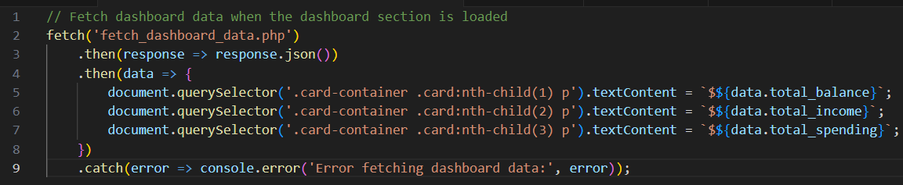

**Usage Instructions**

1. **Start the Local Server**: Make sure your local server is running (e.g., XAMPP).
2. **Access the Application**: Open your web browser and navigate to:

<http://localhost/FinanceDashboard>

1. **Register or Login**: Use the application by registering a new account or logging in with existing credentials.
2. **Use the Dashboard**: Once logged in, navigate to the dashboard to view and manage your financial data.

**Database:**

* Database Structure: Assuming we have a users table in our MySQL database.
* Database Connection:We'll start by creating a reusable database connection file.
* CRUD Operations:we will create a PHP file that performs CRUD operations on the users table.it will separate PHP scripts perform Create, Read, Update, and Delete operations.
  + - 1. Create User (Registration)
      2. Read Users
      3. Update User
      4. Delete User
* HTML Form for CRUD Operations, a simple user interface to interact with these operations.
* Ensure that your PHP environment is correctly configured and that you have the necessary database privileges. Adjust the MySQL connection parameters as needed for your setup.

**Sanitization:**

validation and sanitization in PHP:

1. **Validate and Sanitize Input**:
   * Use filter_var() to validate email addresses and htmlspecialchars() to prevent XSS.
2. **Update the form submission in the PHP script**:
   * Ensure that the form submission is processed securely.

**Wireframe Design:**

* **Home Page:** Overview of total income, expenses, and savings, year-over-year comparison.
* **Dashboard:** Interactive charts, transaction history, and budgeting tools.
* **Profile Page:** User details, dark mode settings, and financial insights.
* **Financial Goals:** Create and track multiple goals, Progress visualization, contribution tracking, goal modification.
* **Budget Management:** Category-based budgeting, real**-**time spending tracking, budget vs**.** actual comparison, custom category creation.

**Future Enhancements:**

* Multi-currency support
* Export functionality for reports
* Mobile app development
* Cloud sync capabilities
* Advanced analytics features

**GitHub Link:**

<https://github.com/samiraQS/Finance-WebApp->

**Website:**

